Analyze International Debt SQL Queries

1. The World’s Bank International Debt Data

SELECT top 5 * FROM international_debt

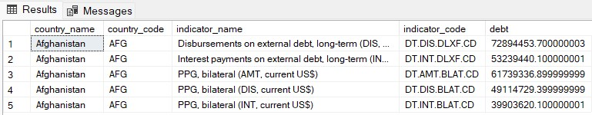

1. Finding the number of distinct countries

SELECT COUNT(DISTINCT country_name) AS total_distinct_countries

FROM international_debt;

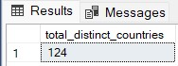

1. Finding out the distinct debt indicators

SELECT DISTINCT indicator_code AS distinct_debt_indicators

FROM international_debt

ORDER BY distinct_debt_indicators;

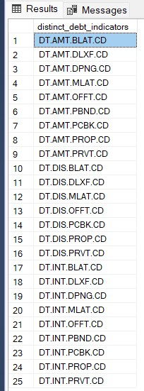

1. The highest amount of principal repayments

SELECT country_name, indicator_name

FROM international_debt

WHERE debt= (SELECT MAX(debt)

FROM international_debt

WHERE indicator_code ='DT.AMT.DLXF.CD');

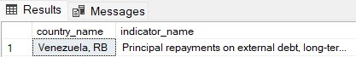

1. The most common debt indicator

SELECT TOP 10 indicator_code,

COUNT (indicator_code) AS indicator_count

FROM international_debt

GROUP BY indicator_code

ORDER BY indicator_count DESC, indicator_code DESC

